Lesson 8 : building MicroPython : 32 bit and 64 bit (Assignment 8)

Command - dpkg --print-foreign-architectures

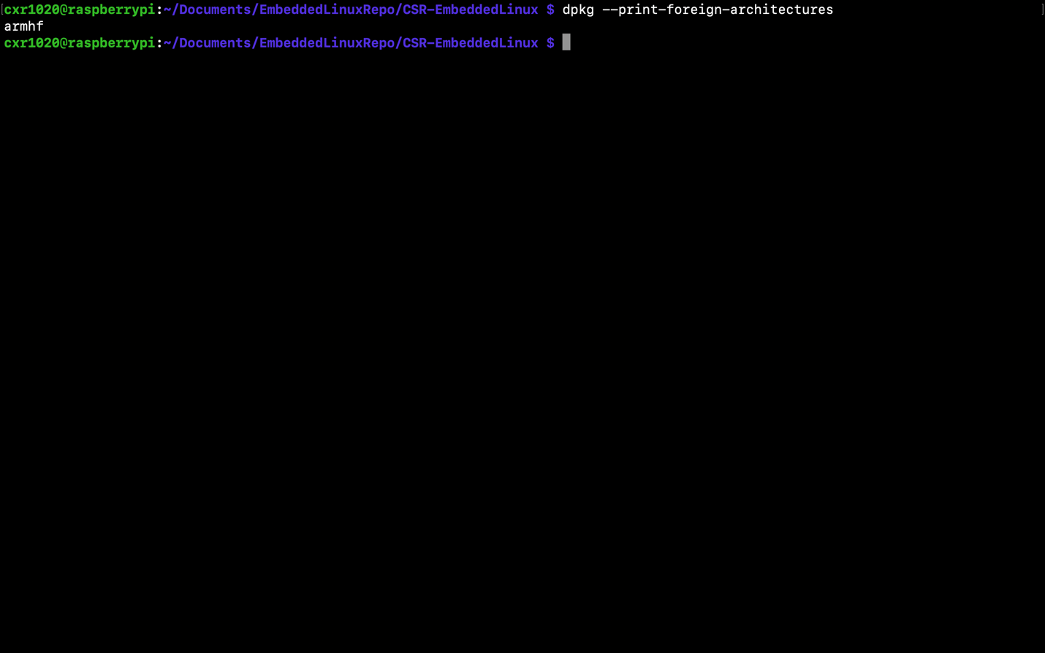

SourceCode - hello_c

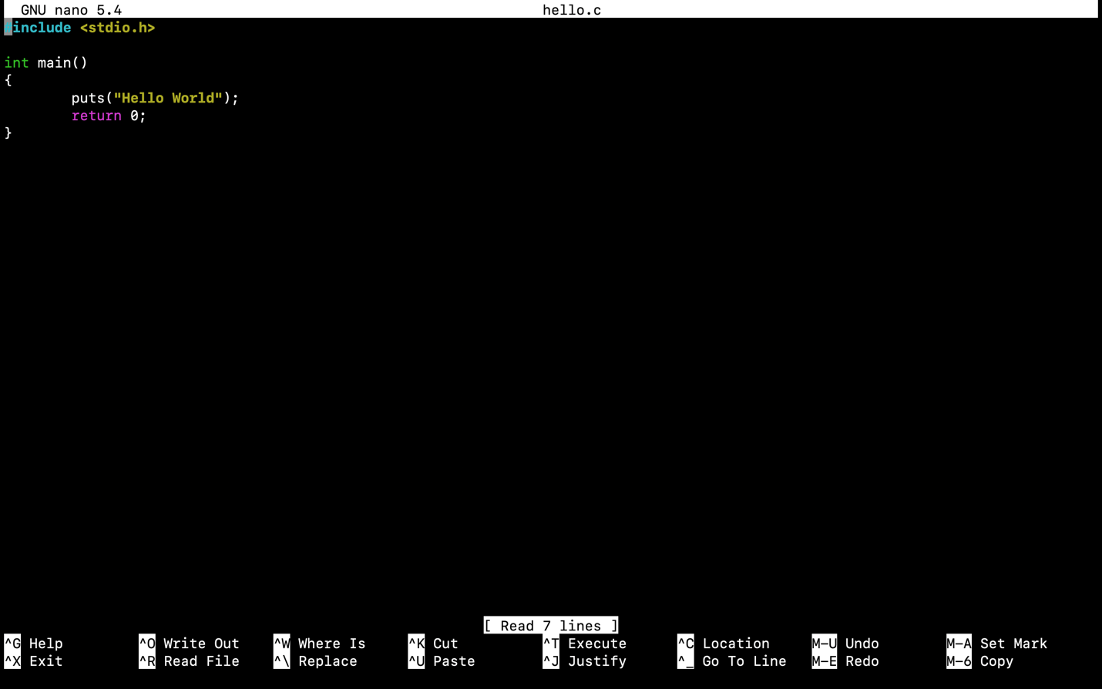

Output – hello64

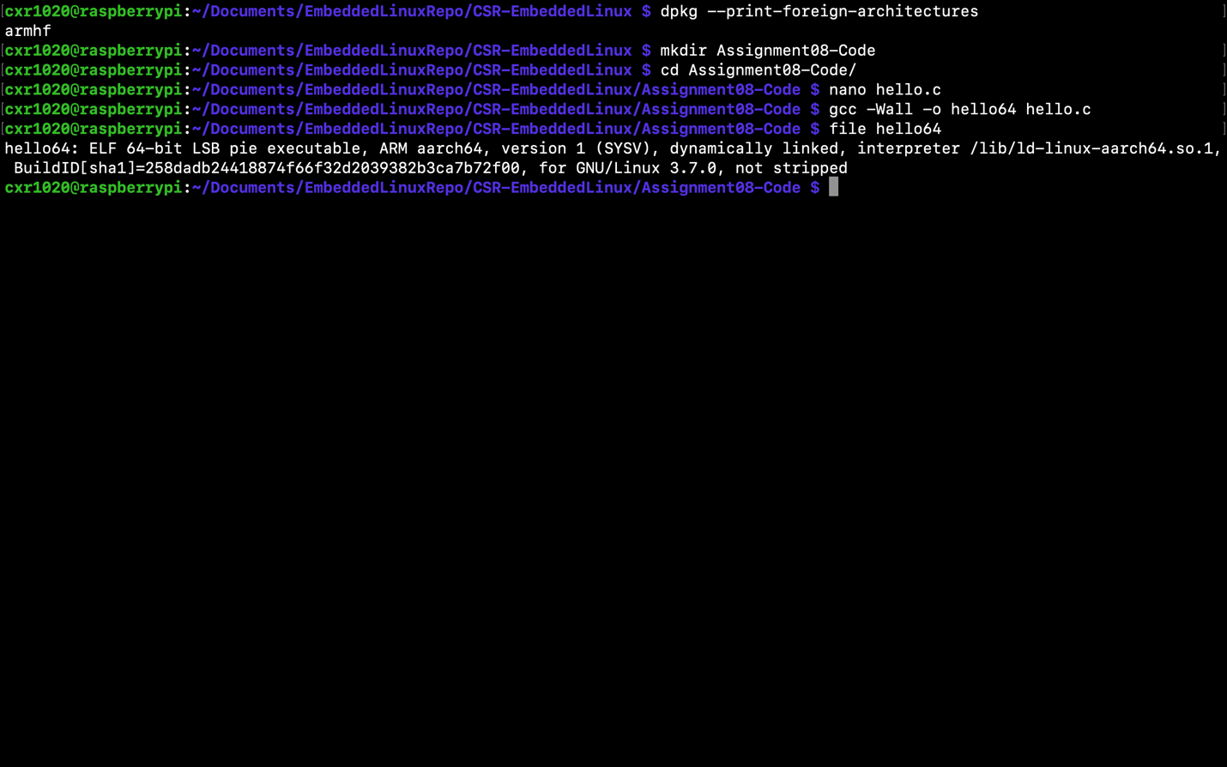

Command - sudo apt install gcc-arm-gnueabihf

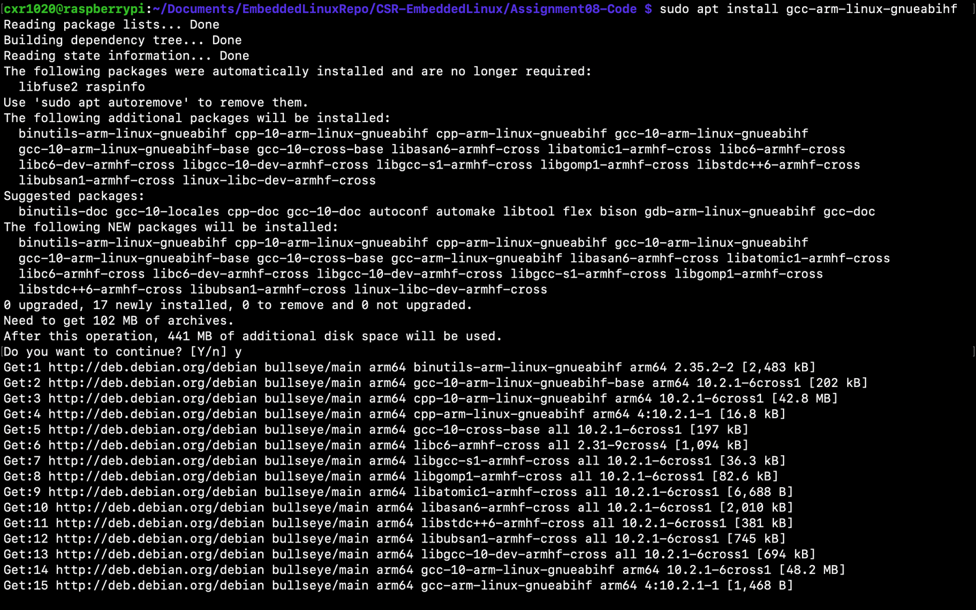

Result - Cross Toolchain

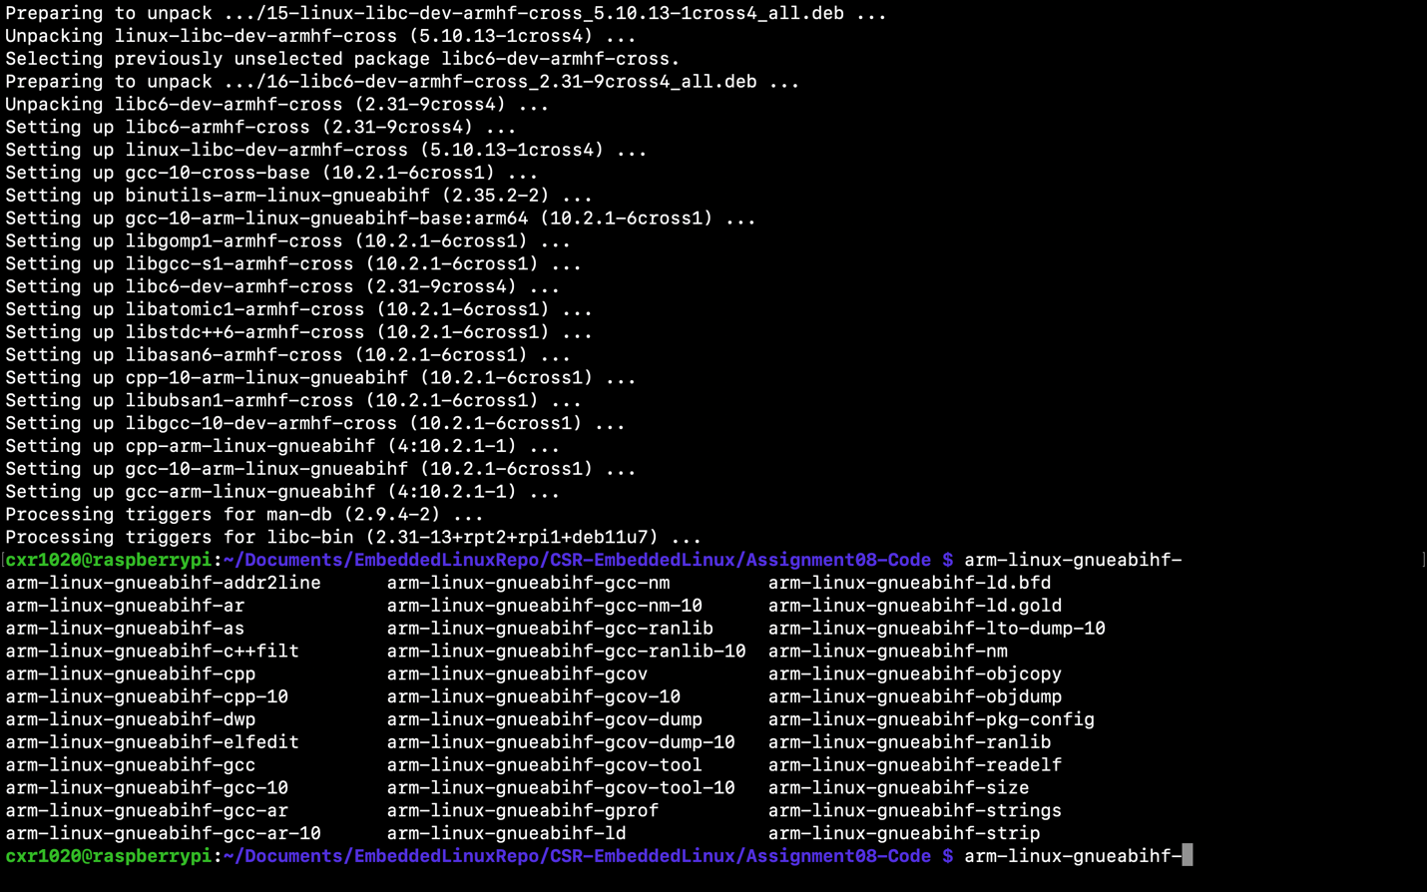

Output - hello32

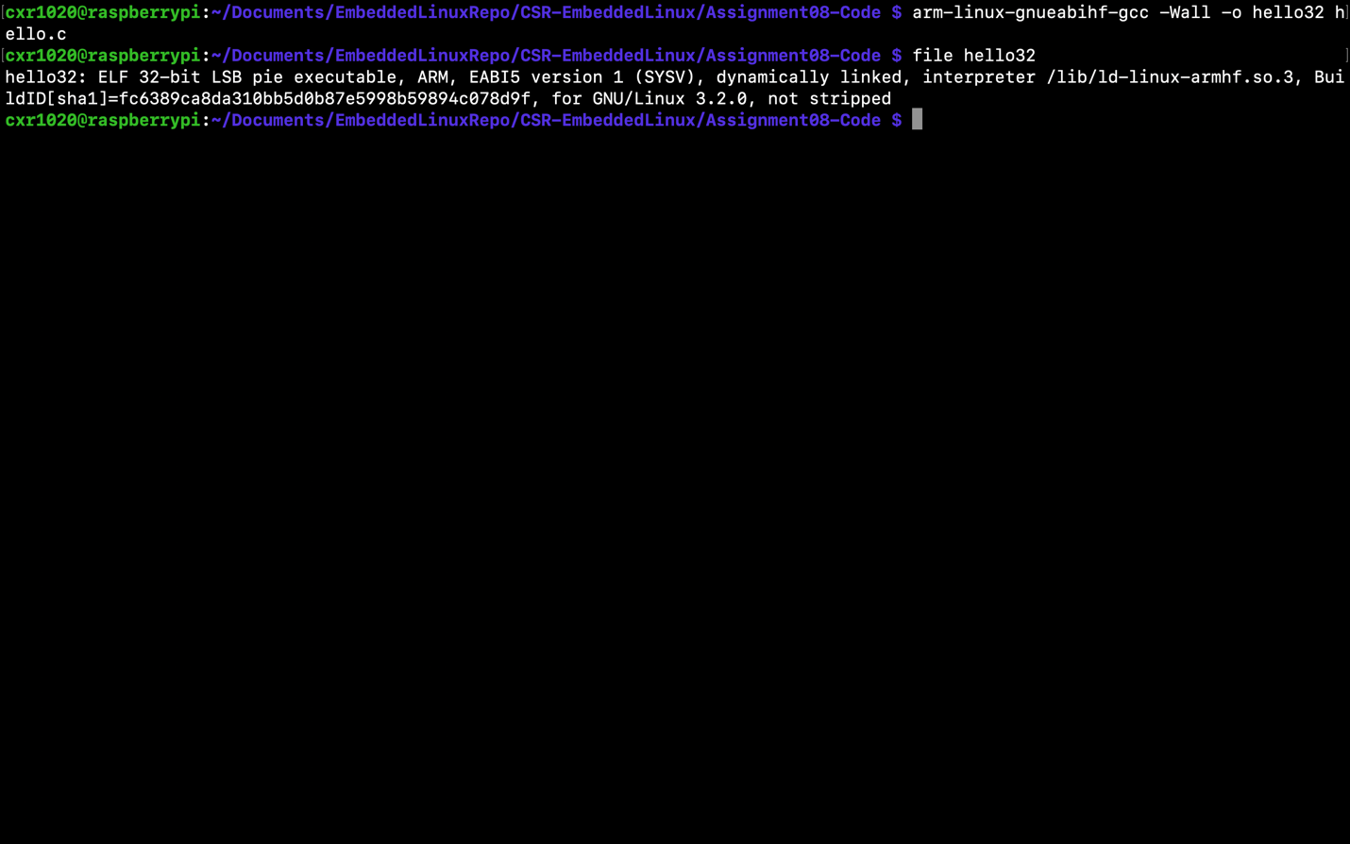

Result hello32 ldd (not a dynamic file)

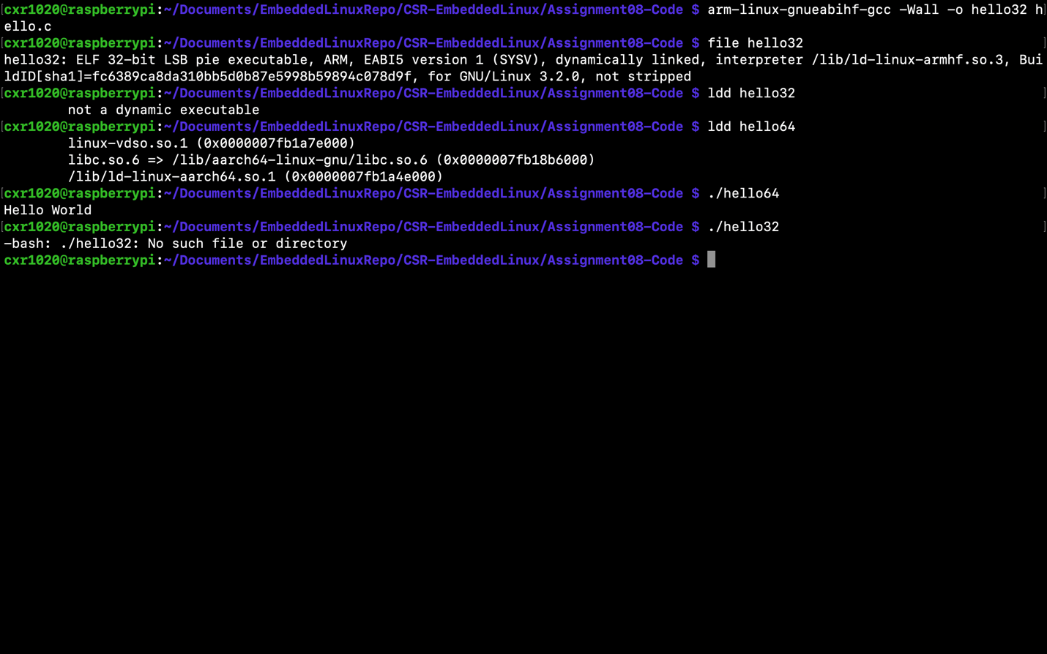

Command - readelf -a hello64 (& hello32 to compare)

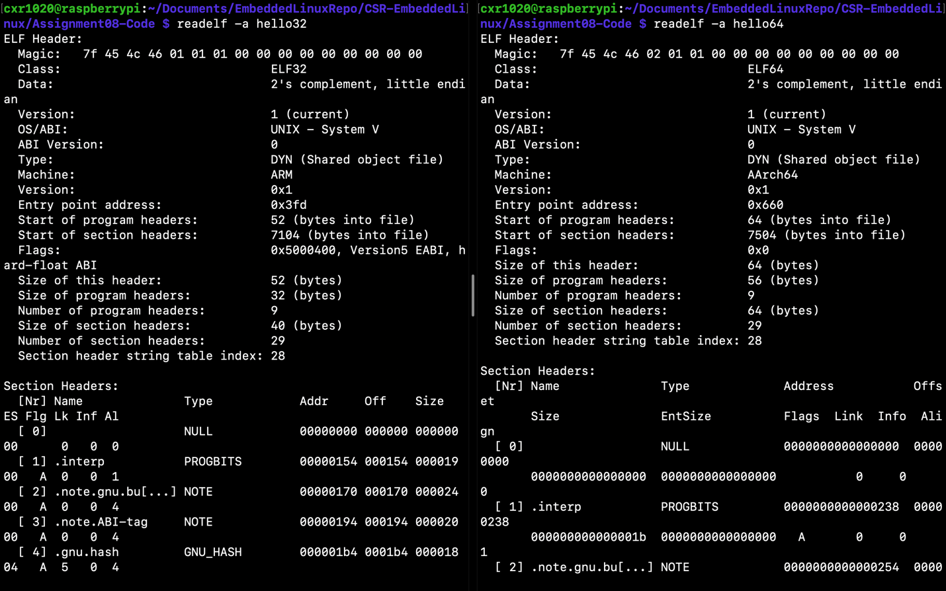

Command - apt-file /lib/ld-linuc-armhf.so.3

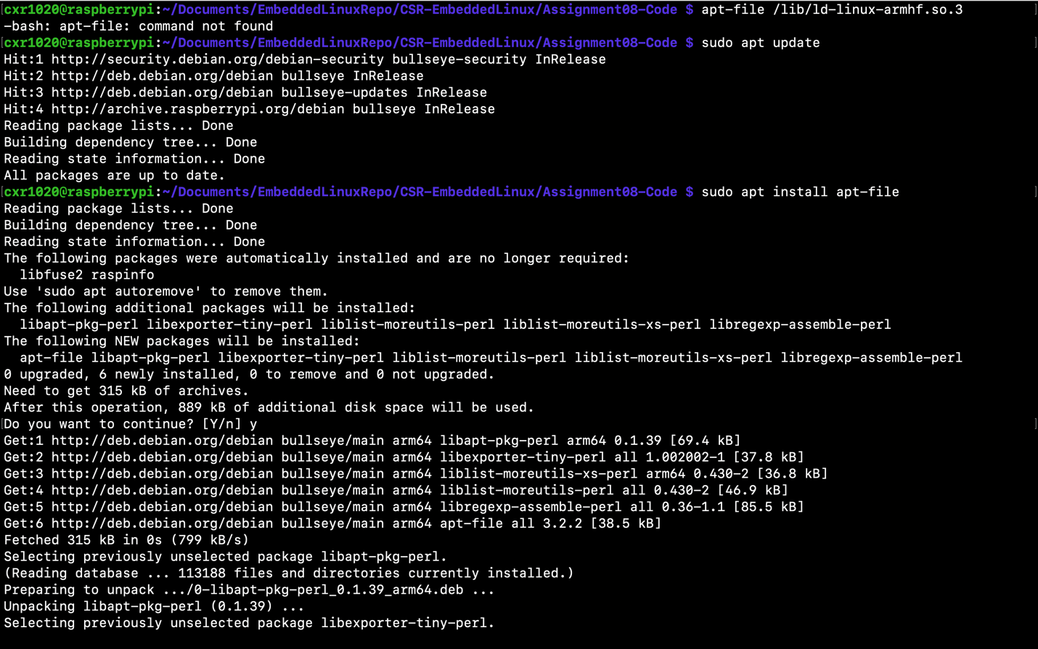

Command - sudo apt-file update (this will update chache to seach /lib/ld-linux-armhf.so.3)(cache is a map of file names to the packages)

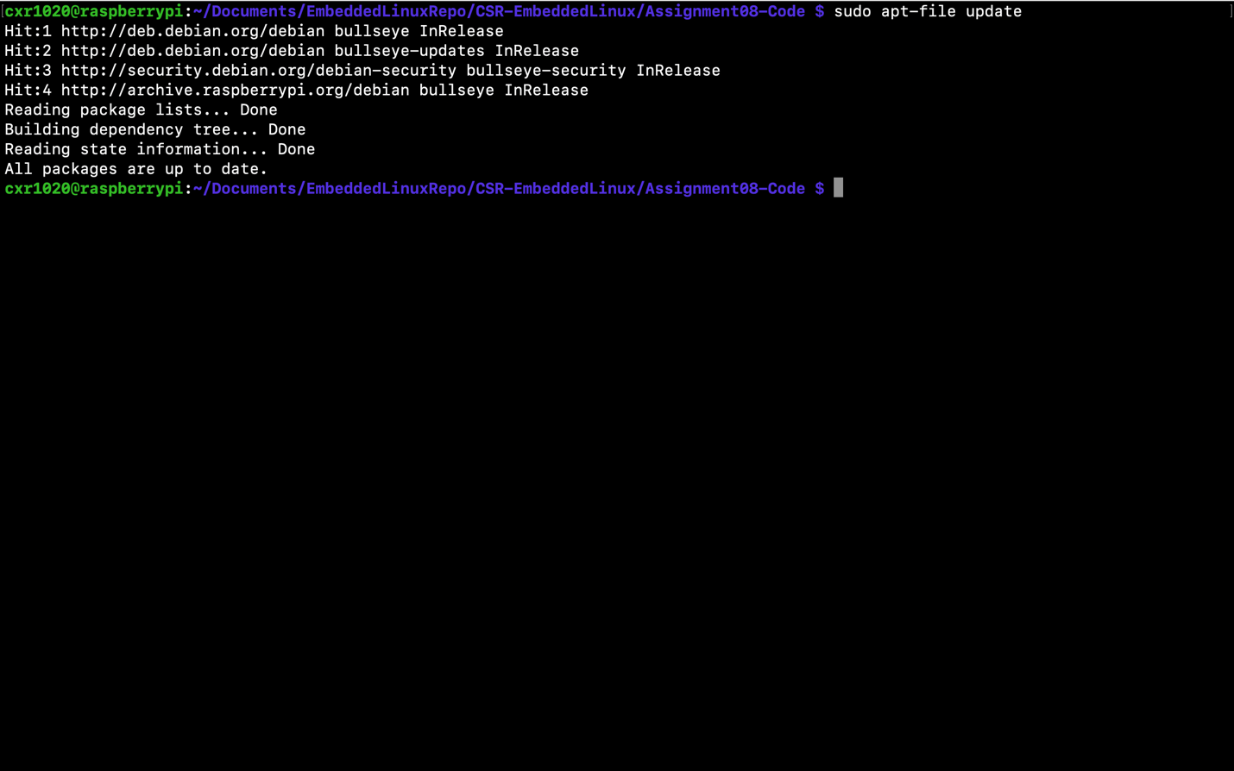

Command - sudo apt-file search /lib/ld-linux-armhf.so.3

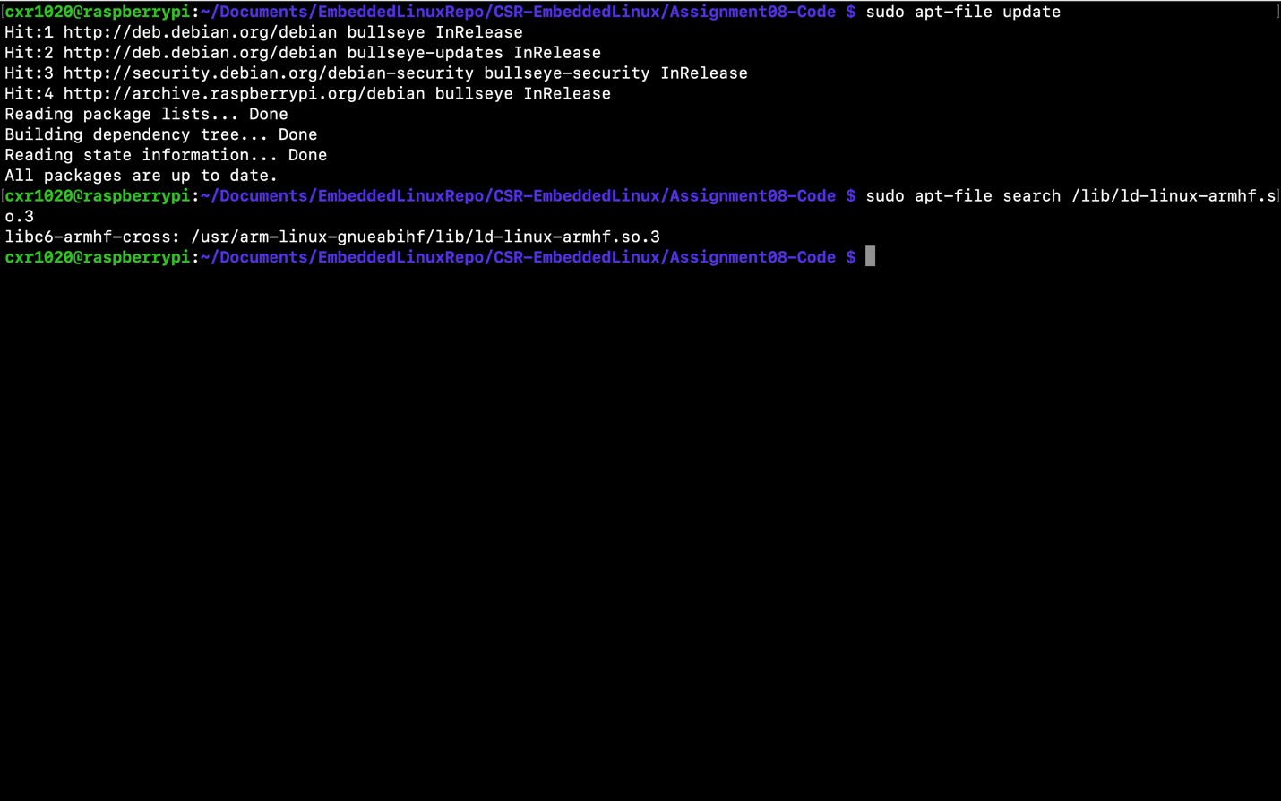

Command - sudo apt install libc6:armhf

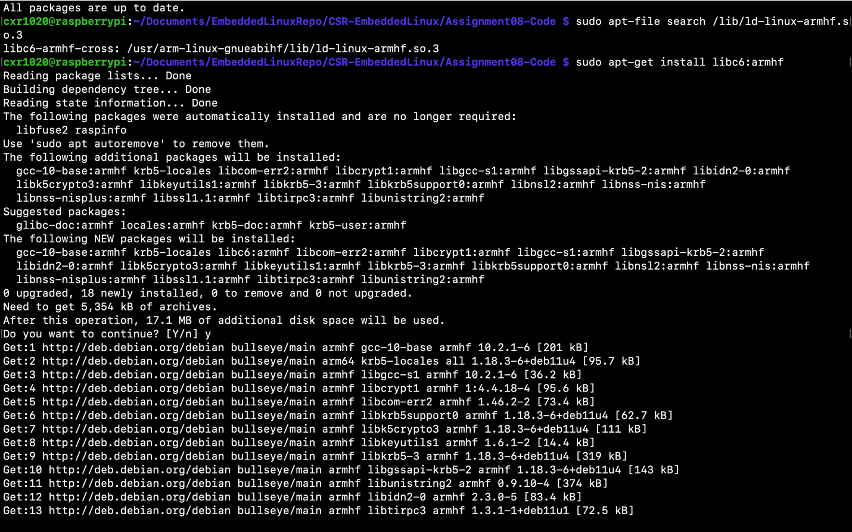

Output - hello 32 (working)

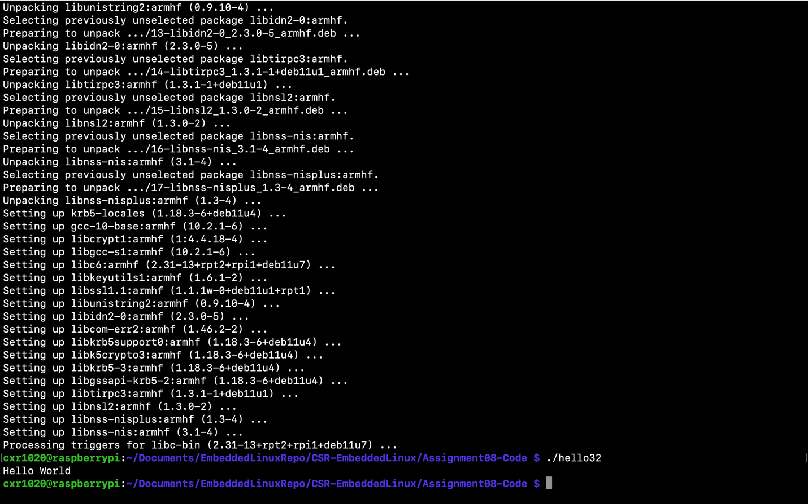

Command - git clone --depth=1 <https://github.com/micropython/micropython>

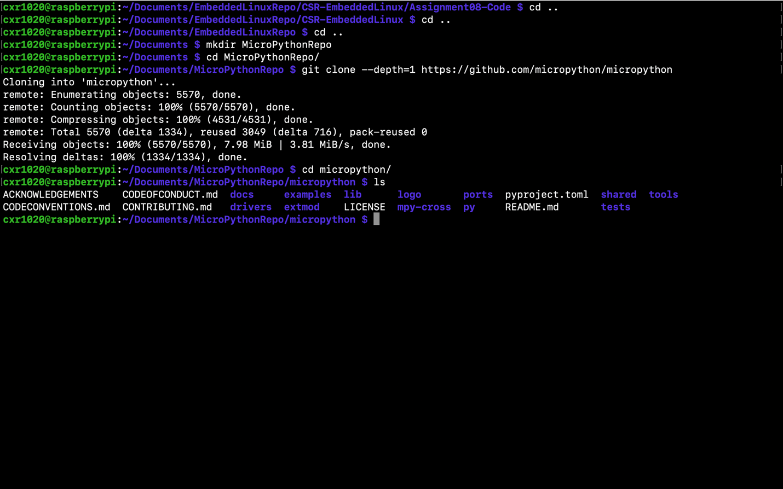

Command - make submodules (for ports/unix)

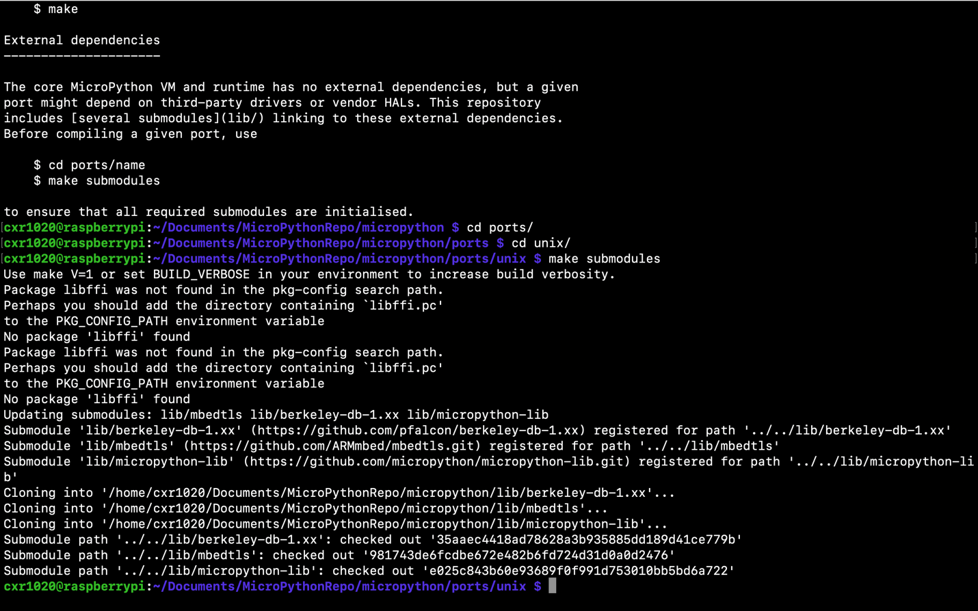

Command - sudo apt install libffi-dev

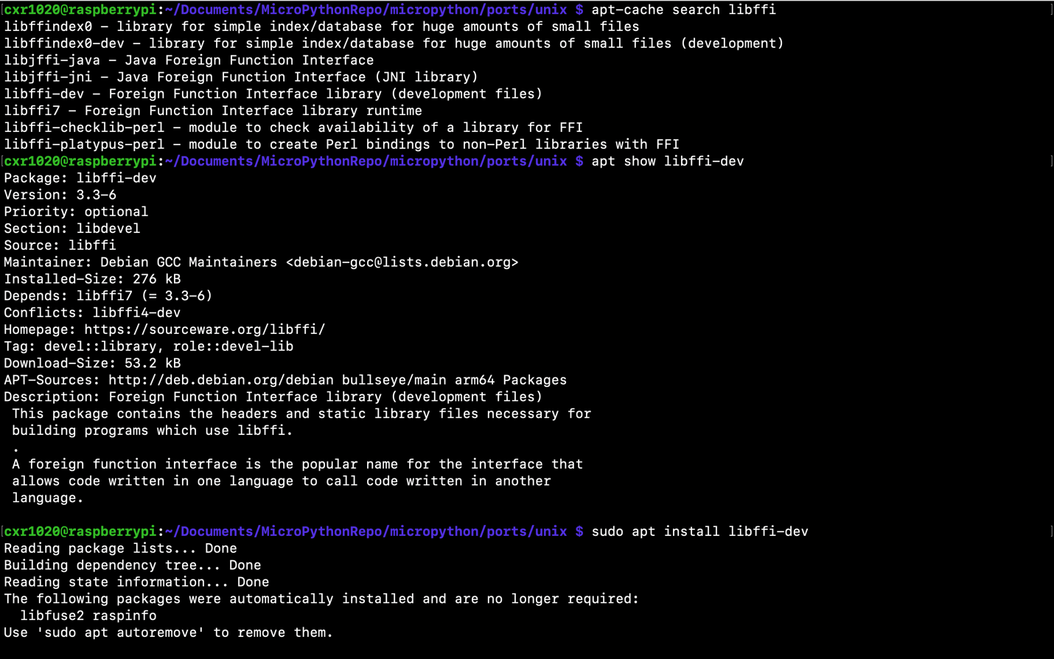

Command - sudo apt install libffi-dev:armhf

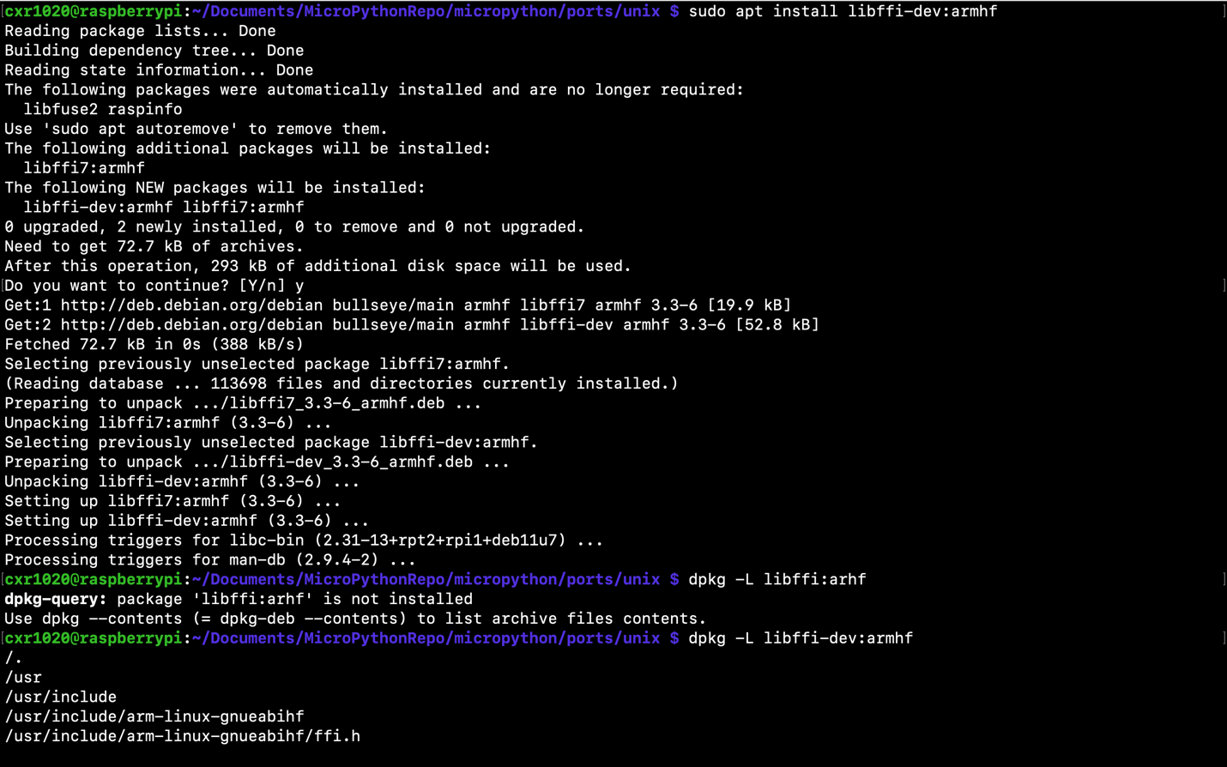

Output - running 64-bit micro python

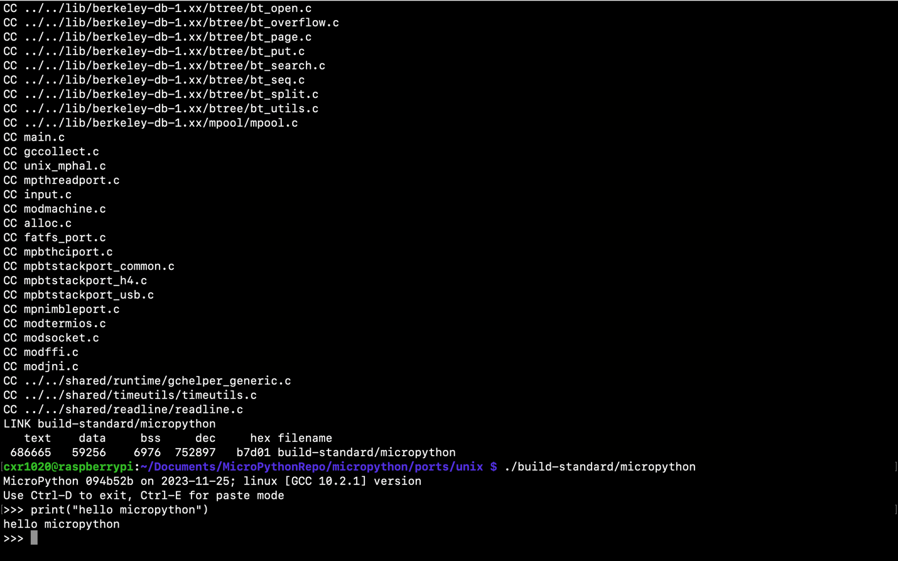

Command - make CROSS_COMPILE=arm-linux-gnueabihf-

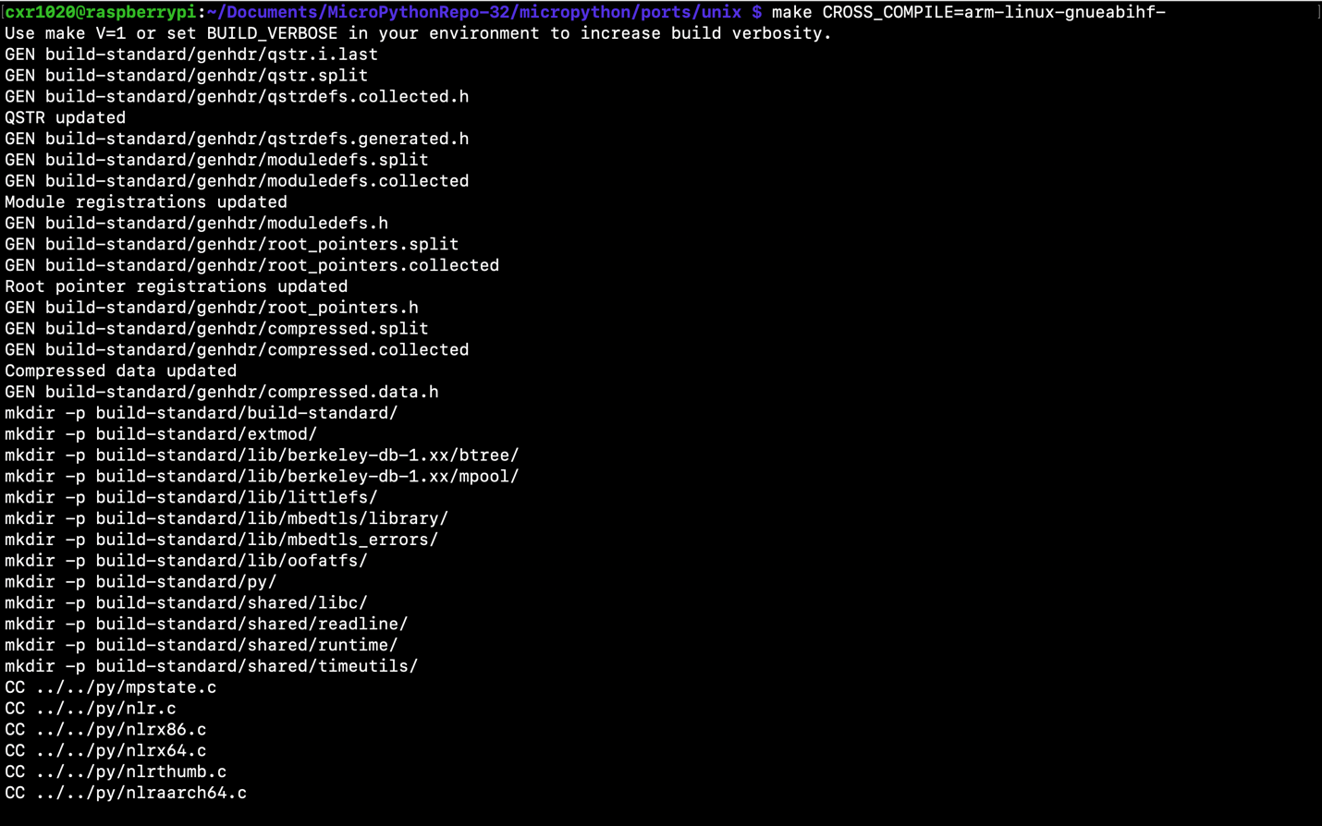

Output - Running micropython (32 bit)

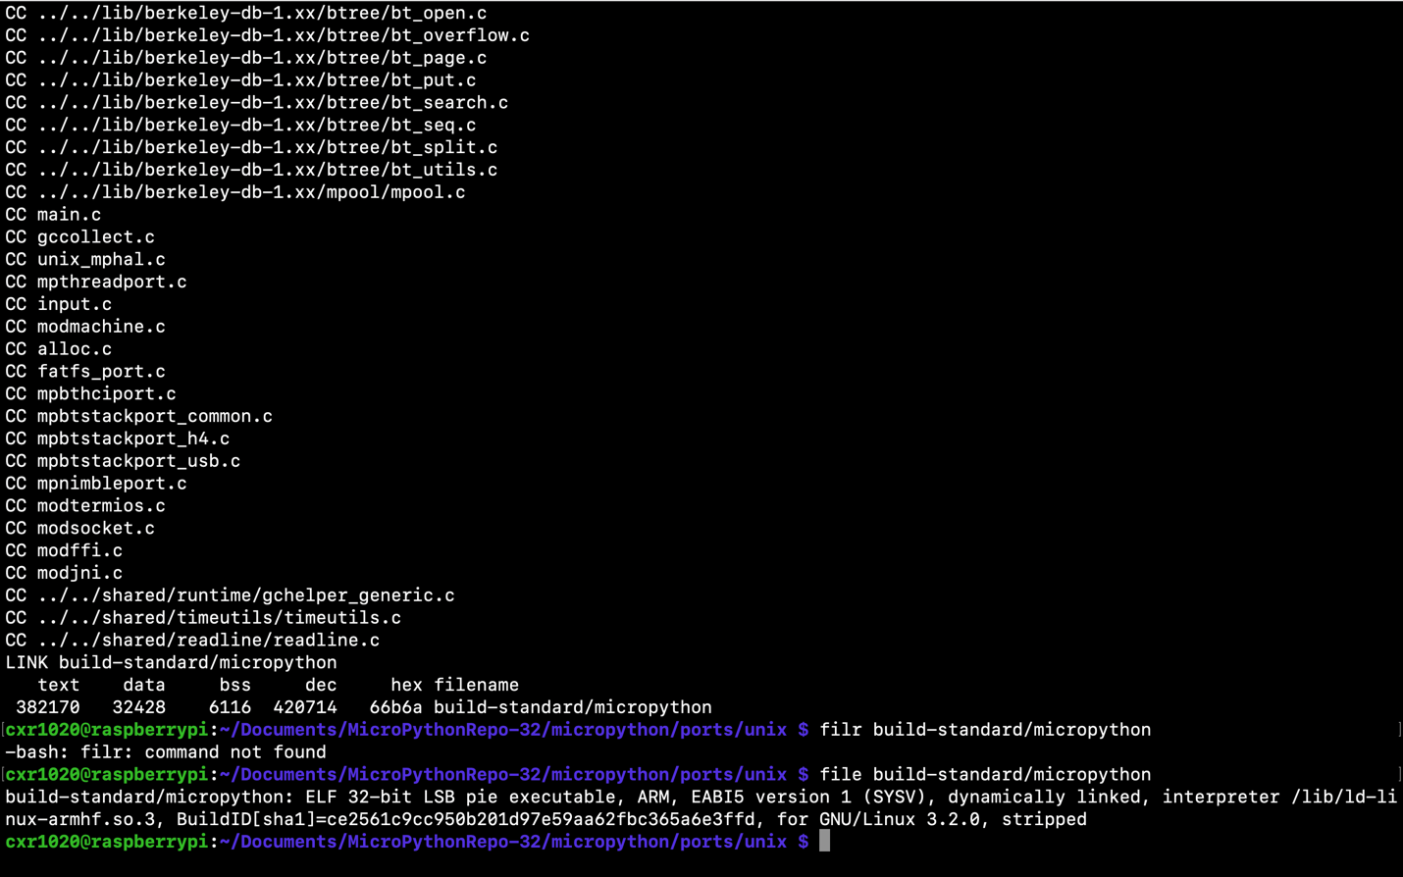

Command - scp ./build-standard/micropython [pi@192.168.1.189:./Downloads](mailto:pi@192.168.1.189:./Downloads)

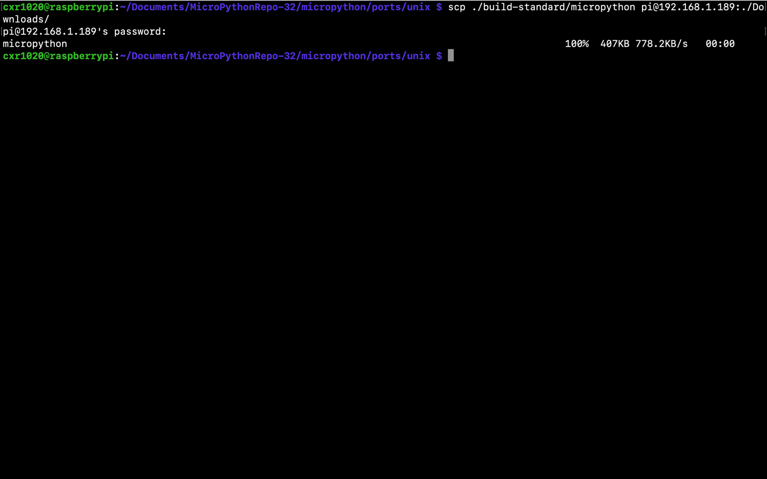

Output - ldd micropython (issue)

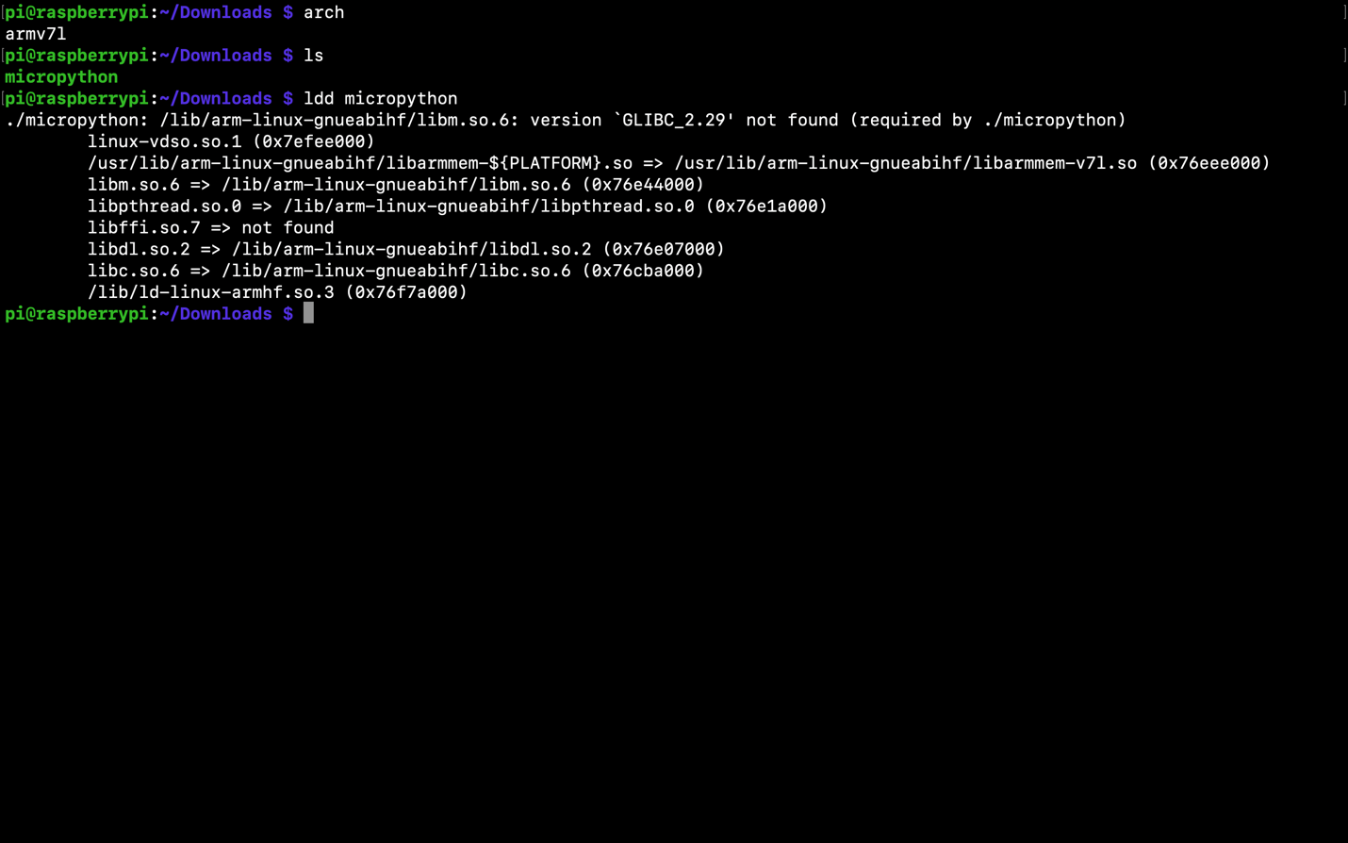

Command - scp correct libffi shared object

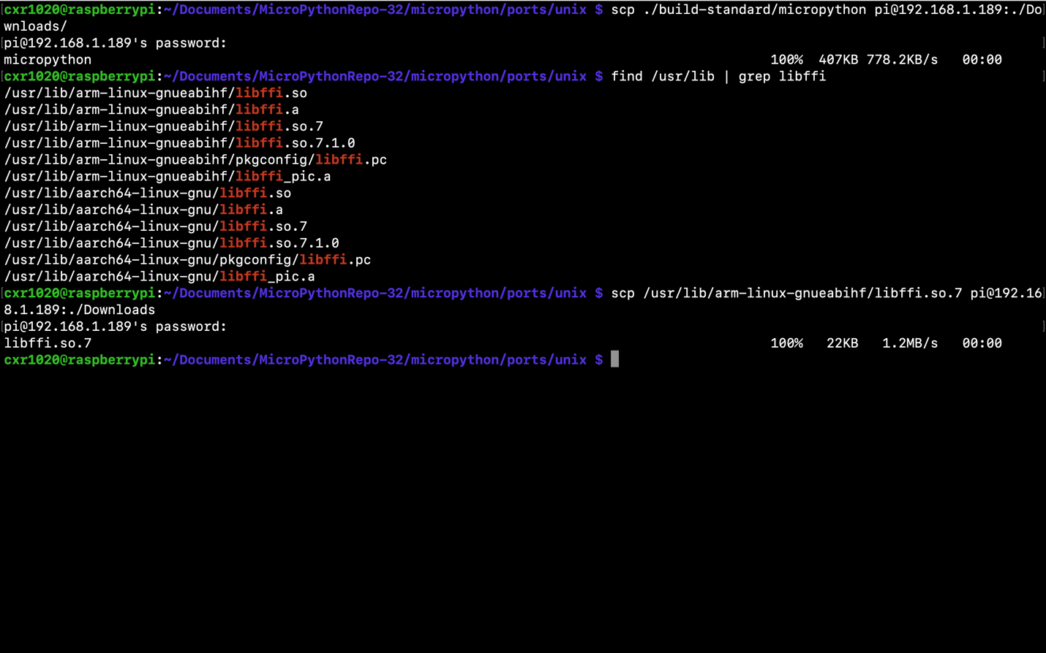

Output - copy correct libffi

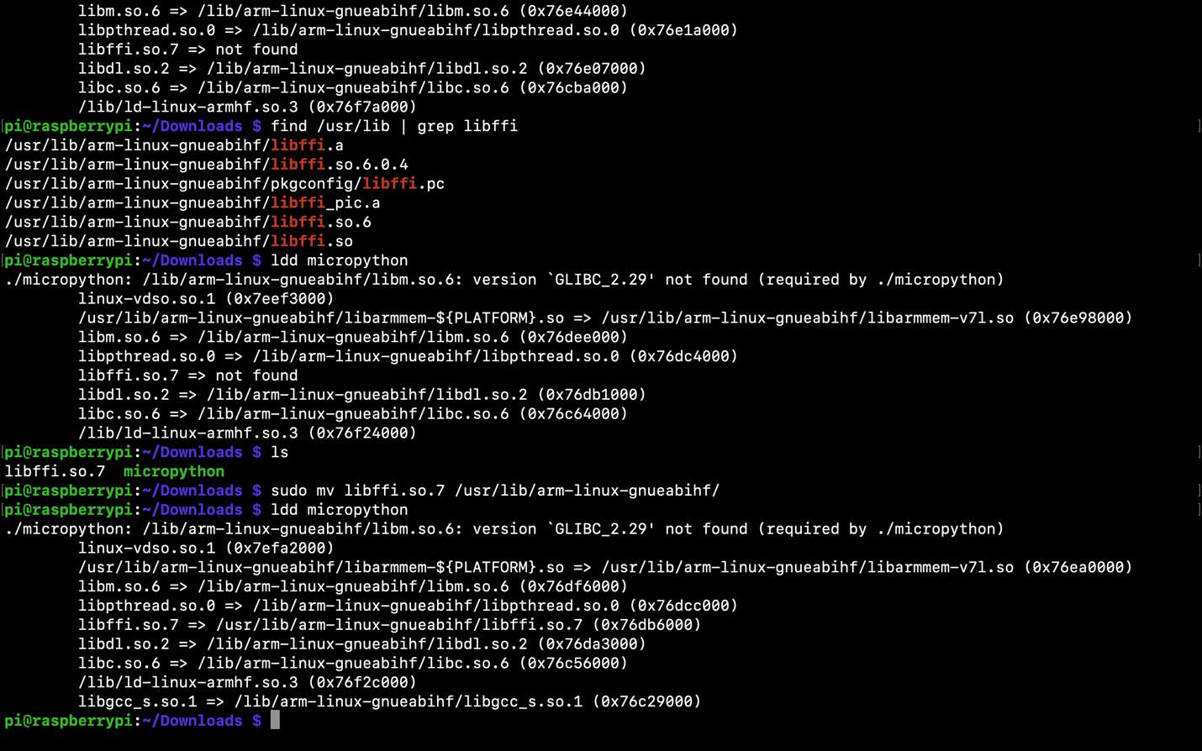

Output – Issue 2

